**PROJECT REPORT**

**A COMPREHENSIVE ANALYSIS OF FINANCIAL PERFORMANCE: INSIGHTS FROM A LEADING BANK**

# 1 INTRODUCTION

## 1.1 OVERVIEW

Analysis of financial performance of the bank using the given data and extract some insights from the data using Business Intelligence tools. As we know the banking sector plays a significant role in the economic growth and development of any country.

## 1.2 PURPOSE

Banks can improve their ideas using technical developments. So people see bank as a safe place to deposit money. They also provide loan for educational improvement and to expand their business.

# 2 PROBLEM DEFINITION AND DESIGN THINKING

## 2.1 EMPATHY MAP

## Screenshot (3).png

## 2.2 IDEATION AND BRAINSTROMING MAP

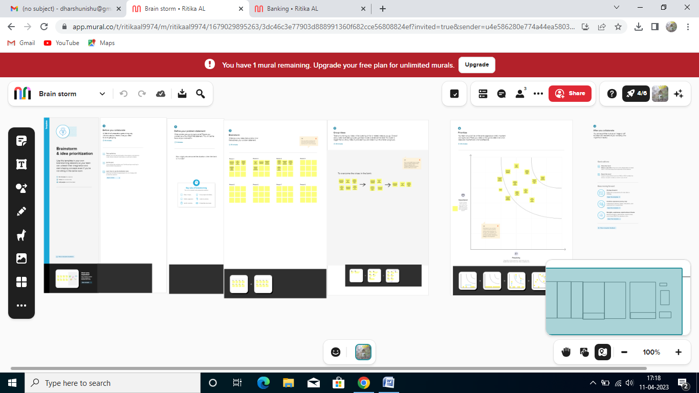

# 3 RESULT

**Dashboard**

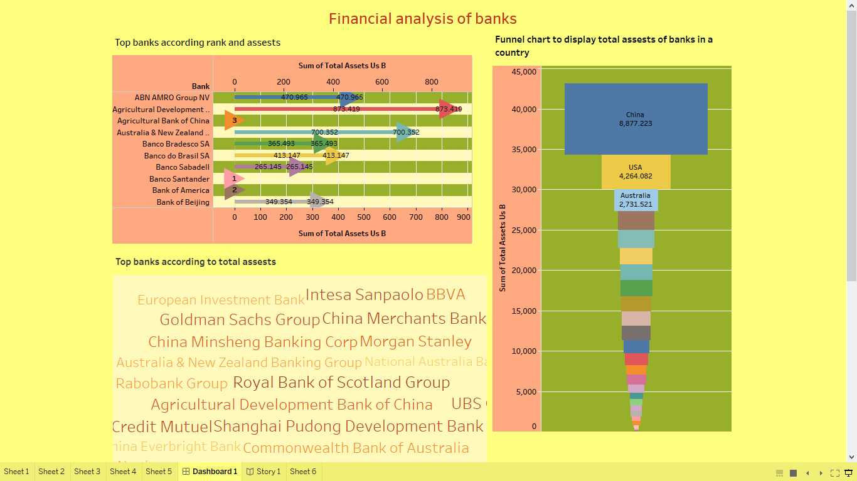

**Story**

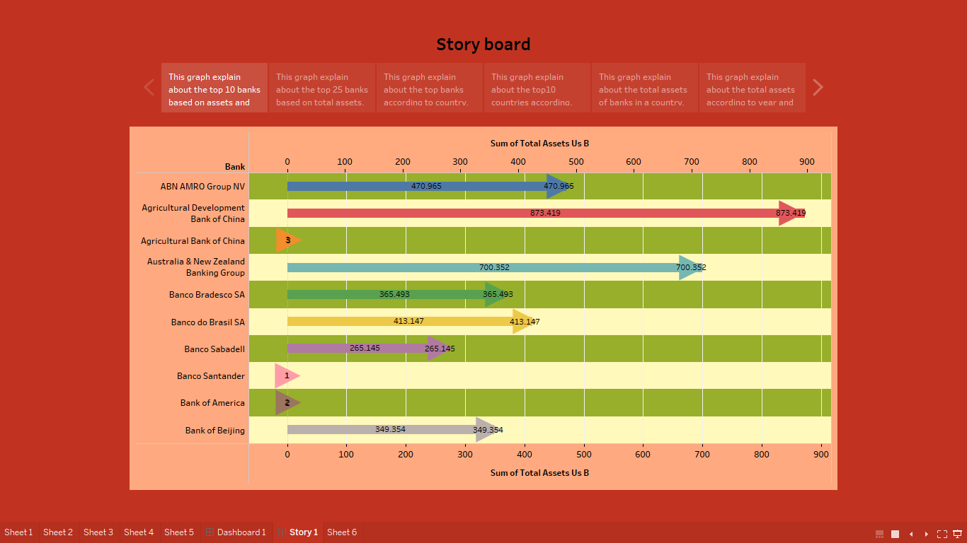

**Web application**

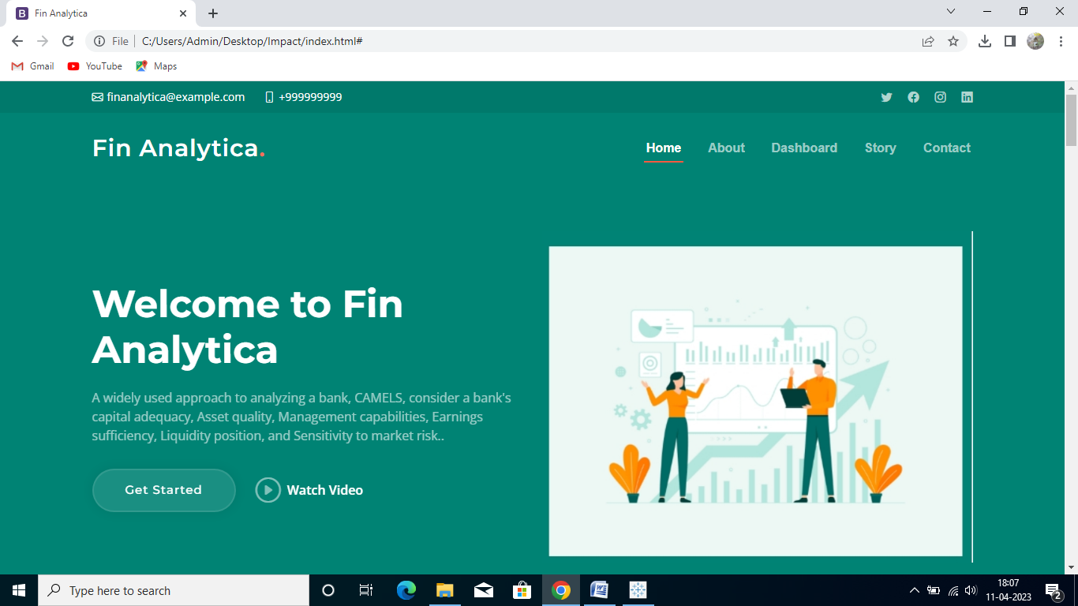



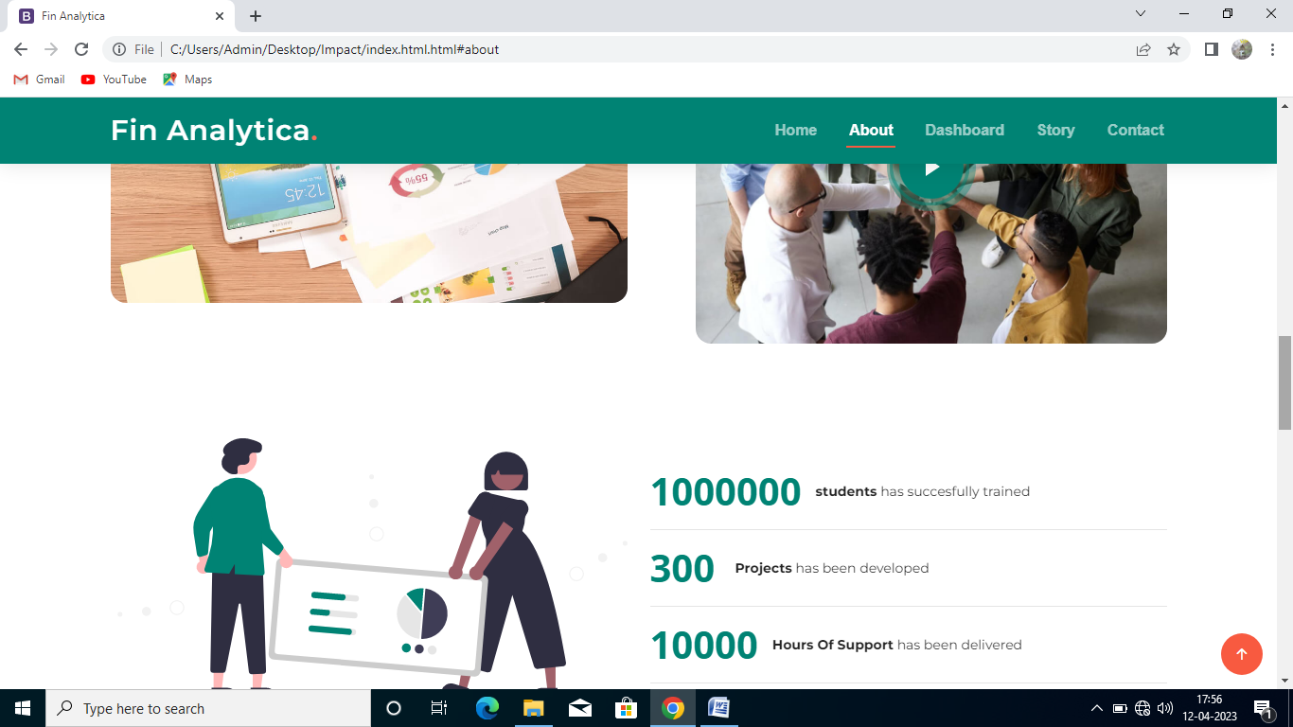

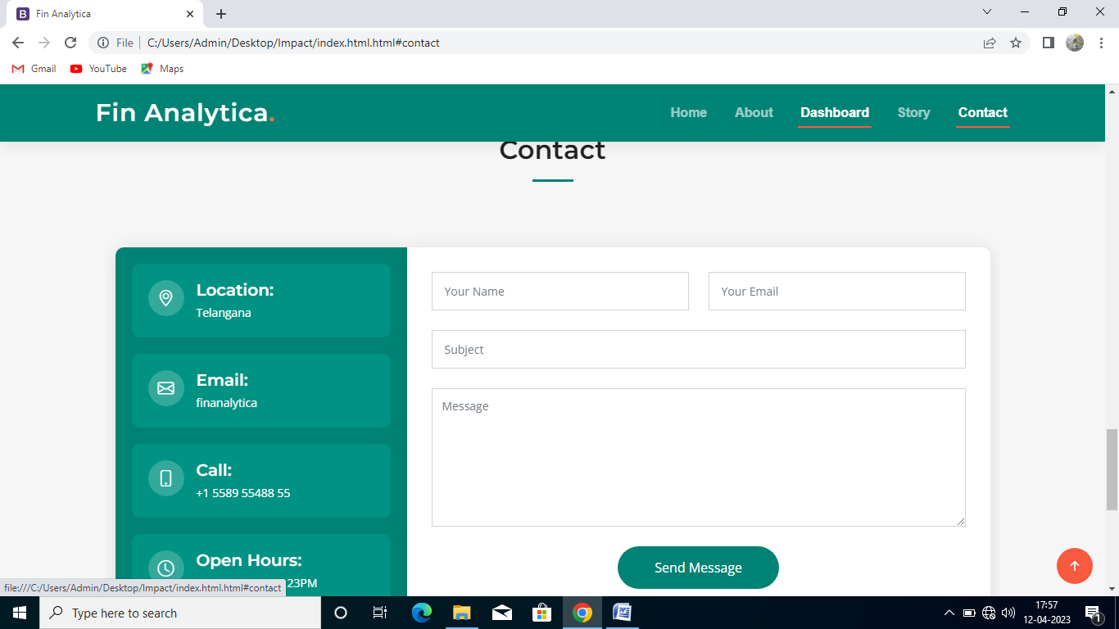

# 4 ADVANTAGES AND DISADVANTAGES

**Advantages**

* By using visualization technique the understanding is more comfortable and easy.
* Benefits of the consumer can be analysed using visualization.
* This visualization helps us to analysis the development in rural areas.
* This visualization mainly helps in implementation of policy.

**Disadvantages**

* Some time there may be technical faults which cause problem.
* Risk of fraud and robberies.

# 5 APPLICATION

# This application is applied in financial sectors, insurance agencies, banks and any financial agencies. In bank to implement new policy this visualization helps to analyze and develop the policy.

# 6 CONCLUSION

Banks plays a critical role in a country’s economic development since they control the supply of money in circulation to a significant extent and are the primary driver of economic growth. The visualization helps in implementation of new policy in a better way. Since the visualization is more comfortable to understand.

# 7 FUTURE SCOPE

In this developing world the data analysis has a major role and it will have a drastic development in this technical world. So this makes easier to analyze a problem and find a solution.

# 8 APPENDIX

**A. Source Code**

